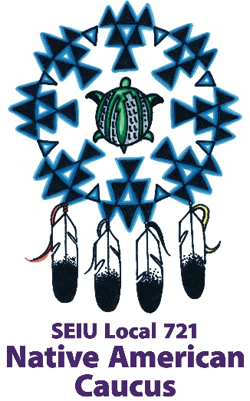

The Native American Caucus is committed to educating everyone by sharing the experiences, cultures, and practices of indigenous people. Utilizing a conciliatory perspective, we increase participation regionally among the diverse SEIU Local 721 membership by addressing social, economic, and justice issues — and by developing leadership, promoting respect, improving communication, fostering understanding, and creating a culture of inclusion.

Funding Request Checklist

Attend at least 2 caucus meetings within prior 12 months to be considered for funding (does not need to be consecutive meetings)
Provide project/event budget and available relevant materials in support of funding request
Deposit check timely
Include caucus logo on project/event materials as agreed
Provide additional project/event materials as needed
Present follow-up report at caucus meeting (caucus meets every 2nd Thursday of the month)
Funding Application
Please print clearly
Organization: |  |  |  | Date:
Requestor name: |  | Title:
Full address for mailing check, including routing (dept, attn, etc.):
Description of funding purpose (include date of event):
Description of target community:
Attach budget documents for event/project (e.g., spreadsheet)
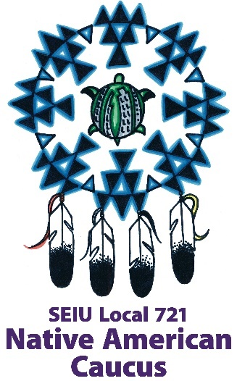
Funding Agreement

In consideration of an approved funding request from the SEIU Local 721 Native American Caucus, the undersigned agrees to the following:
- To deposit funds promptly upon receipt of the check
- To provide any agreed upon placement of the Caucus logo on related organizational materials
- To present a report on use of the funds at the Caucus meeting in the month following the event, or other mutually agreed-upon Caucus-meeting date
- To forward materials related to the funded purpose (e.g., event flyers, registration links, photos, brochures, etc.)
Signature |  |  |  | Date
Print name |  | Title
Organization |  | Amount funded

